Title: The Title of the Survey

PI: Y. R. Name, Observatory Somewhere, SomeCountry
CoIs: S. Friend, University 1, OneCountry; B. Good, AnotherUniversity, AnotherCountry; O. More, SomeInstitute, YetanotherCountry

Survey type: Participating Community Survey / Non-participating Community Survey

1 Abstract (10 lines)

2 Scientific rationale and immediate objectives (up to 3 pages + 2 pages for figures)
Discuss the scientific background of the project; state what are the scientific objectives of the survey. It would be beneficial to put the proposed survey in the international context of past, present and future surveys.

3 Survey type justification (up to 1 page)
Discuss the choice of survey type. If Participating elaborate on the scientific synergies and advantages on sharing the focal plane. If Non-Participating describe the scientific motivation and advantages of this choice. See also the Survey Policies webpage.

4 Survey metrics (up to 3 pages)

This section should include the following standard information to facilitate the work of the PSP.

- Targets distribution as a function of RA
  - RA bin width: 1 hour
  - Separated histograms for LR and HR
  - Please see the example plot from the “4MOST Survey Strategy Plan”

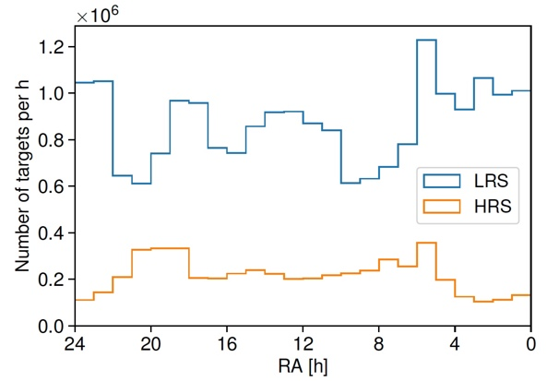

- Targets distribution as a function of magnitude
  - Use either G band GAIA magnitude (Vega) or Cousins R band magnitude (AB)
  - Bin in magnitude: 0.1 mag
  - Separated histograms for HR and LR
  - Please see the example plot below:

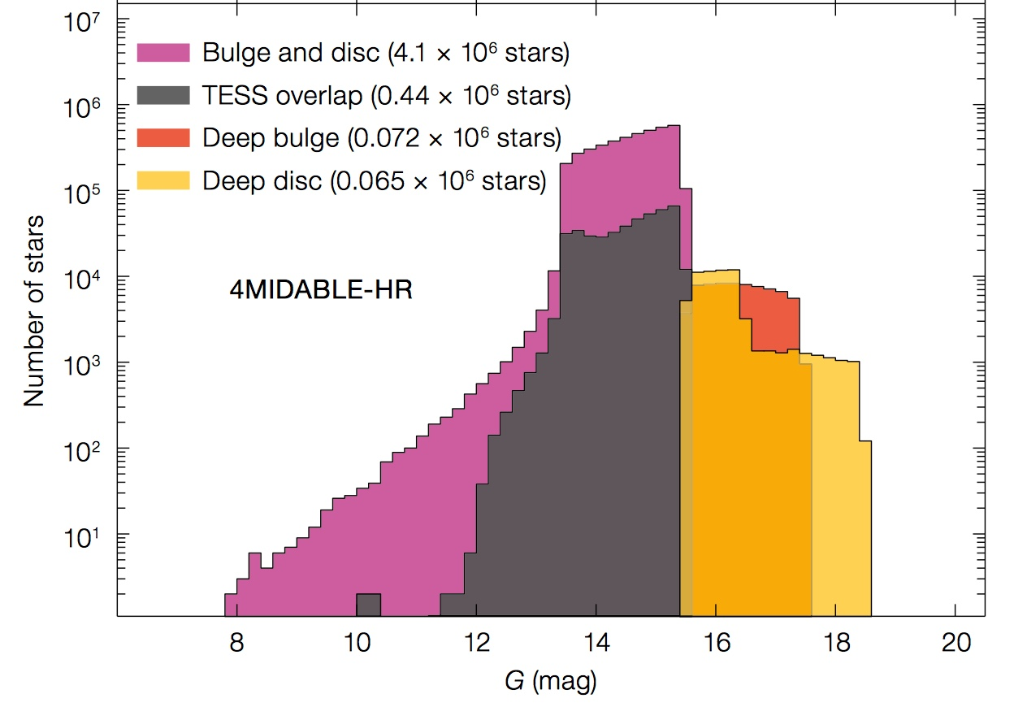

- A table containing the following columns:

Survey regions | RA  (deg) | Dec  (deg) | Area  (deg²) | Spectrograph (LRS/HRS) | Range of targets density (targets/deg²) | Range and average t_{exp}  (hours) | Magnitude range | Execution Priority

- Survey regions: a contiguous patch of the sky covered by the survey (e.g. COSMOS field, or a single stellar cluster)
- Magnitude range: G band GAIA magnitude (Vega) or Cousins R band (AB)
- Execution priority: the relative priority of the execution of a survey region over the other regions of the same survey along the 5 years survey time. For Participating surveys the time of the observations for a given target of a give survey in a given region will be the result of the optimization of the overall Science Team Survey programme, but it could be useful for the PSP to have an indication of the priority between the different regions proposed by one survey. For Non-Participating surveys it would be useful to schedule the allocation of half-nights along the five years.

5 Observing strategy and required observing conditions (up to 1 page)

Participating surveys should refer to the Messenger article and the following webpage were the survey strategy is described. Special needs compared to the current Consortium survey strategy plan (e.g. cadence) should be described here, although it is not ensured that it will be possible to implement them.

Non-Participating surveys should describe their observing strategy, observing conditions and other observational needs (e.g. cadence).

6 Fibre time justification (up to 1 page)
Provide a detailed justification of the fibre time need to achieve the science objectives of the survey based on the survey strategy. The 4MOST ETC should be used. Comment of the properties of the targets in terms of contiguity and clustering.

7 Description of the responsibilities, resources and experience within the proposing team (up to 1 page)

8 Description of the data products and justification of their legacy value (up to 1 page)

9 Other remarks, if any (up to 1 page)

