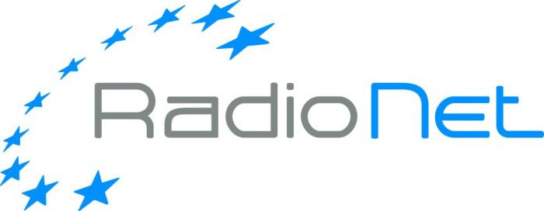

Request for RadioNet support for
scientific events

- Call text
- The application form to be used
RadioNet support for scientific events
Call

RadioNet is an EC funded project, which brings together the premier radio astronomical facilities in Europe to serve a growing research community across all of Europe and beyond. The EC funds in this programme are dedicated among others to disseminate the scientific highlights and the development on the technological front within the context of the RadioNet infrastructures and to provide a platform for the most effective promotion of the results of the RadioNet activities.

RadioNet is inviting organisers of scientific events (e.g. conferences, workshops) to respond to the call using the application form. Especially the events focussing on scientific results achieved using the RadioNet facilities and/or technical developments of RadioNet activities are encouraged. Additionally, we would like to welcome also cross-disciplinary events, with the aim to feed the collaboration between radio astronomers and scientists working in other bands of the electromagnetic spectrum. This will disseminate the knowledge acquired in our field to the broader astronomical community and at the same time will broaden the scientific horizon of radio astronomers. You are welcome to contact the Dissemination activity leader – Dr. Tiziana Venturi (tventuri@ira.inaf.it) for more information about the RadioNet scientific dissemination programme.

Funding will be provided to support, in particular, young/female/expert participants and to cover a share of the organisation cost (see the funding principles).

Please send the duly filled in application form as PDF file to RadioNet@mpifr.de
Deadline: February 15th, 2017, 5pm

The duly submitted applications will be evaluated by the Selection Committee. The results will be announced within 3 weeks after the submission deadline.
The event organizers and supported participants are expected to acknowledge the RadioNet support at all event advertisement media. The event organisers must provide an assessment report based on the provided template within one (1) month after the event. There is a 3-month time limit after the event for claiming the expenses, and upon the submission of the assessment report.

Do not hesitate to contact the RadioNet office for any assistance.

Sincerely,
RadioNet Management (RadioNet@mpifr.de)

Funding principles:
- Cost must be actually incurred in connection with the RadioNet action and necessary for its implementation
- Cost must be identifiable and verifiable, in particular recorded in the accounts in accordance with the accounting standards. Cost must comply with the applicable national law on taxes, labour and social security
- Travel costs and related subsistence allowances (including related duties, taxes and charges such as non-deductible value added tax (VAT) paid by the beneficiary) are eligible if they are in line with the beneficiary’s usual practices on travel.
- Cost must be reasonable, justified and must comply with the principle of sound financial management, in particular regarding economy and efficiency (i.e. in line with a good housekeeping practice when spending public money, avoiding monetary excesses).
‘Economy’ means minimising the costs of resources used for an activity (input), while maximising quality; ‘efficiency’ is the relationship between outputs and the resources used to produce them.

Examples:
1. The beneficiary may NOT increase the remuneration of its personnel, upgrade its travel policy or its purchasing rules because of the European Commission support.
2. Entertainment or hospitality expenses (including gifts, special meals and dinners) are in principle not eligible.
3. Tips, which are not obligatory, are not eligible. By contrast, in some countries the invoice of the restaurant includes a certain mandatory amount as payment for the ‘service’. In this case, the amount may be considered eligible — if the other eligibility conditions are fulfilled.
4. Cost of cancelled trips/events cannot be reimbursed.

Eligibility for funding:
Researchers throughout the world can participate in the Horizon 2020 projects - though they are not always eligible for H2020 funding. Regarding funding, we can distinguish between countries that are automatically eligible for funding and those that are not. For more information click here: http://ec.europa.eu/research/participants/docs/h2020-funding-guide/cross-cutting-issues/international-cooperation_en.htm

RadioNet strongly advices that at least 2/3 of the support will be allocated to the support of participants (travel, lodging and meals expenses) and up to 1/3 to other costs. Reasons for any other allocation need to be clearly explained in the request form.

RadioNet support for scientific events
Application form
Event Information
Title
Place
Organiser
Date
No. of participants
Total event cost
Other sources of funding | Please specify the other sources of funding and their level
REQUEST
(max. 2 pages)
Requested contribution [EURO] | Please specify the level of the requested RadioNet support [EURO]
Use of the RadioNet contribution | Please specify in detail the use of the RadioNet support, indicating the expenses (e.g. who, how much, for what, selection criteria) and keep in mind the goal of RadioNet.
How the event fits in the RadioNet framework | Please specify the scientific impact of the event on the RadioNet community.
Relevance of the event | Please specify the science / development related to the RadioNet facilities
Ethics | Please specify how you will address the ethic issues (e.g. gender, ethnic)

For more information about the RadioNet scientific dissemination programme please contact the Dissemination activity leader – Dr. Tiziana Venturi (tventuri@ira.inaf.it)

